**DAILY ONLINE ACTIVITIES SUMMARY**

|  |  |  |  |  |  |  |  |  |
| --- | --- | --- | --- | --- | --- | --- | --- | --- |
| **Date:** | 21/05/2020 | | | | | **Name:** | D Richard Franklin | |
| **Sem & Sec** | Fourth SEM section A | | | | | **USN:** | 4AL18CS020 | |
| **Online Test Summary** | | | | | | | | |
| **Subject** | | Microcontroller and Embedded Systems | | | | | | |
| **Max. Marks** | | 30 | | **Score** | | | 27 | |
| **Certification Course Summary** | | | | | | | | |
| **Course** | Complete Python Bootcamp : Go from zero to hero in Python 3 | | | | | | | |
| **Certificate Provider** | | | Udemy | | **Duration** | | | 2 Hours |
| **Coding Challenges** | | | | | | | | |
| **Problem Statement:** 1. To demonstrate the process of SRTF scheduling  2. To remove duplicate elements from a SLL | | | | | | | | |
| **Status:** Completed | | | | | | | | |
| **Uploaded the report in Github** | | | | | YES | | | |
| **If yes Repository name** | | | | | <https://github.com/richard3658/lockdown-coding> | | | |
| **Uploaded the report in slack** | | | | | YES | | | |

**Online Test Details:**

The online test was from module 1 which was about Introduction to the subject and the fundamentals of ARM processor. There were 30 questions and the duration was 30 minutes. The questions were optimal and were easy. The score that I received was 27/30.

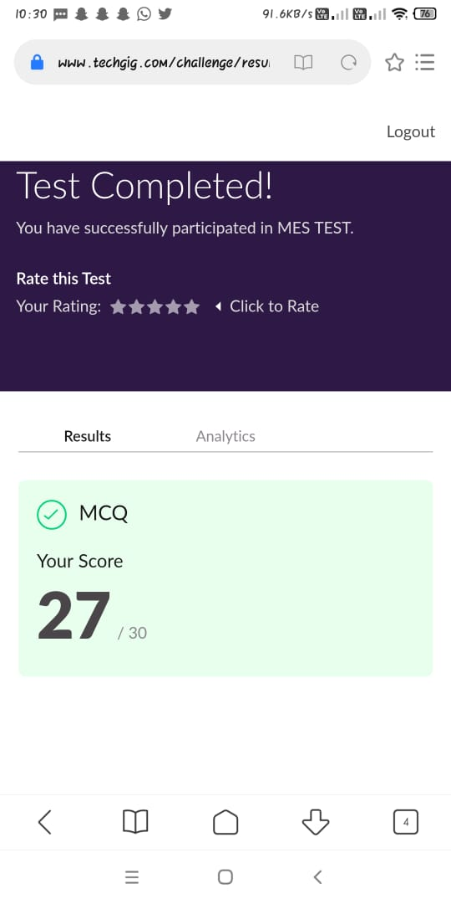

**Certification Course Details:**

**Name of the course**: Complete Python Bootcamp: Go from zero to hero in Python 3

**Certificate Provider**: Udemy

This course has 19 sections and the total duration is 24 hours.

In the fourth day I went through the sections of the course and learnt how a method in python can be created and used. I also learnt the quite some available built-in functions which helps in many ways while coding.

**Snapshot:**

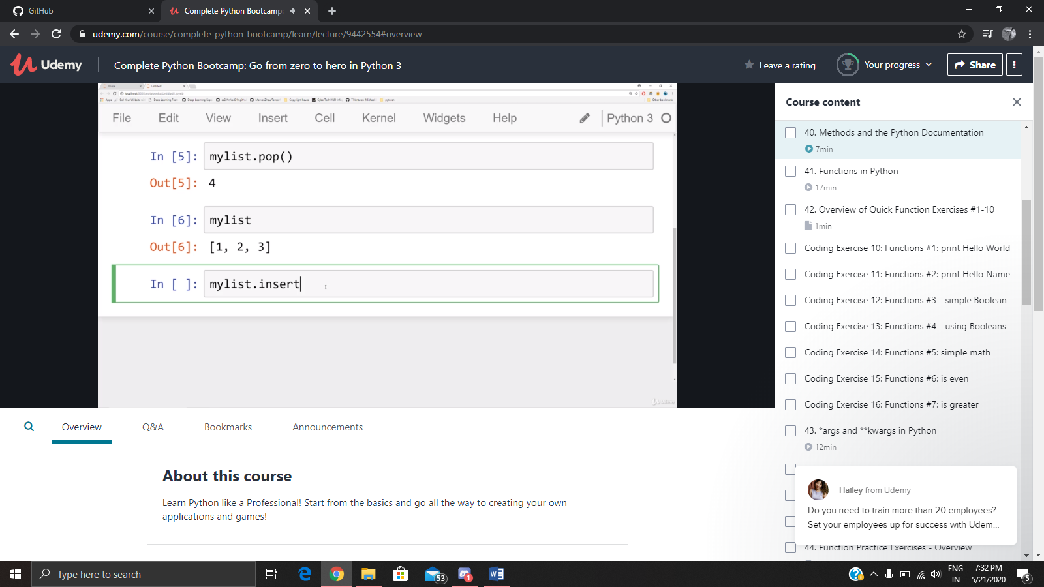

**Online Coding Details:**

Problem 1: (using C language) Write a program to demonstrate SRTF(Shortest Remaining Time First) scheduling process.

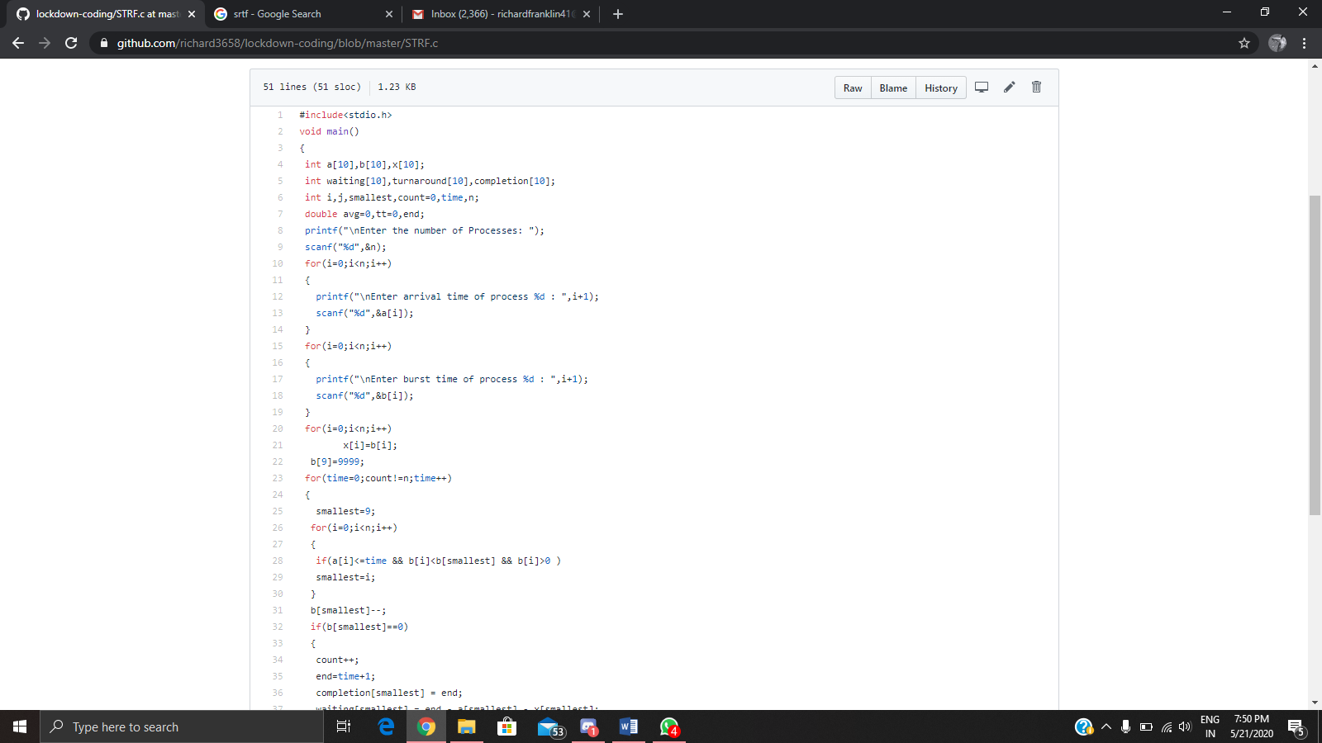

Problem 2: (Using C) Write a program to remove duplicate elements from a singly linked list

